**2025 Flood projection Report**

**(26-AUGUST till 5-September)**

***National Disaster Management Authority (NDMA) - Pakistan***



1. **Combined Drivers of the Flood**

**1. Cross-Border Flow Inputs**

1. The **Chenab** enters Pakistan at the Marala Headworks after receiving inflows from its upstream catchment areas in Indian Illegally Occupied Jammu and Kashmir (IIOJ&K) and Himachal Pradesh. Just north of Marala, the Jammu and Munawar Tawi rivers also merge into the Chenab.

Following record rainfall (up to 600mm recorded in certain parts of Jammu) in the northern catchment areas of the Chenab, Jammu and Munawar Tawi rivers—combined with substantial water releases from the Salal and Baglihar dams by the Indian authorities—a sudden and intense surge of inflows was recorded at Marala Headworks during the night of August 26–27 (please see Figure 1 below). During this first wave (wave-1) of the flood, the discharge at the headworks rose sharply from 200,000 to 1,100,000 cusecs, a peak last observed on August 26, 1957.

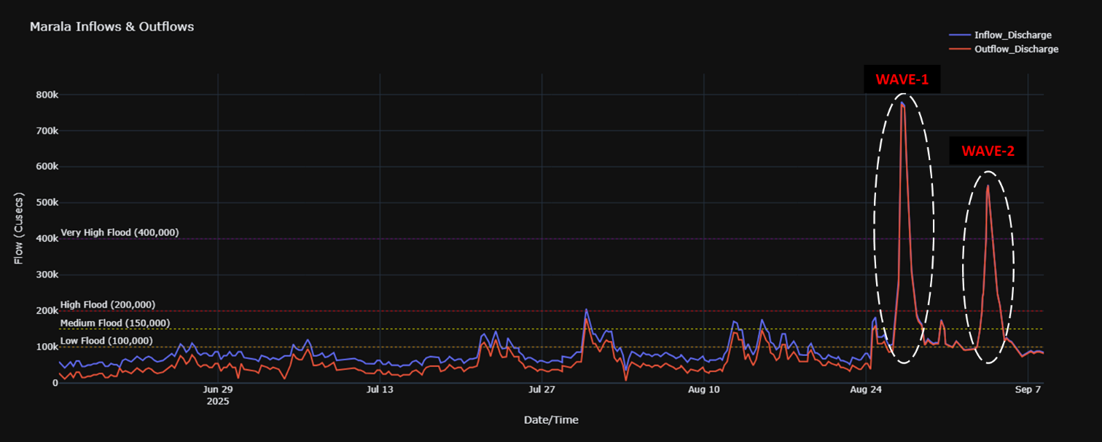

Figure Flood waves 1 & 2 at **Marala** Headworks

1. The **Ravi** river originates in Himachal Pradesh, flows through Pathankot (IIOJ&K), and enters Pakistan near Kot Naina in Narowal District. Its flows are regulated by the Thein (Ranjit Sagar) Dam at Pathankot, making the river highly sensitive to upstream releases and water management decisions by Indian authorities.

In late August, the reservoir at Thein Dam quickly attained to danger levels due to record rainfall in the upper catchments. Without prior intimation, Indian authorities abruptly opened the spill gates, releasing more than 220,000 cusecs downstream. No regulated discharge was ensured by the Thein dam management which resulted in uncontrolled horizontal flows. At the same time, intense basin-wide rainfall further compounded the situation and upstream tributaries of the Ravi also swelled to extreme levels, with Bein, Basantar, and Beig nullahs contributing significant inflows at Narowal district in Pakistan.

The combined effect of vertical (rainfall-induced) and horizontal (dam-released via IIOJ&K) flows led to an exceptionally high flood in the Ravi. At Kot Naina, peak inflows of nearly 290,000 cusecs were recorded, followed by 237,000 cusecs at Jassar. The floodwaters further surged downstream, reaching 217,660 cusecs at Shahdara and 116,335 cusecs at Balloki on August 28.

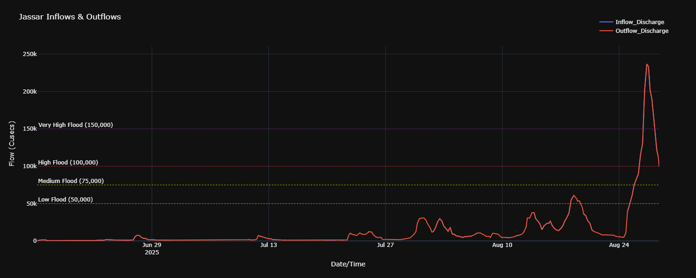

Figure Surge at **Jassar** Ravi

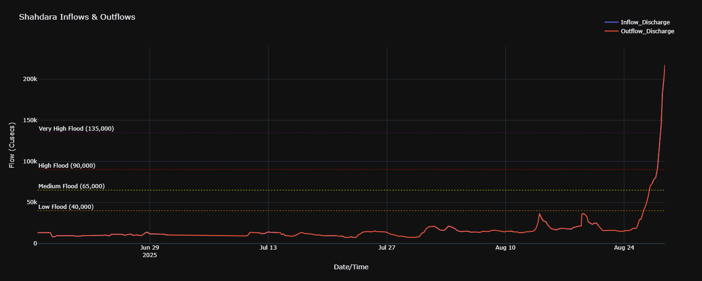

Figure Surge at **Shahdara, Lahore** on the Ravi

1. The **Sutlej** river originates in Himachal Pradesh and flows through the Indian states of Himachal Pradesh and Punjab before entering Pakistan near Kasur at Talwar Post and Ganda Singh Wala. Its flow into Pakistan is regulated by major Indian reservoirs, including the Pong and Bhakra Dams.

On 26 August 2025, the Technical Committee of the Bhakra Beas Management Board (BBMB) decided to incrementally increase discharges from Pong Dam, which had reached its danger level of 1,390 ft, releasing over 80,000 cusecs downstream into the Beas River. Similarly, Bhakra Dam on the Sutlej River reached its danger level of 1,680 ft, leading to a discharge of more than 60,000 cusecs. At the Harike confluence of the Beas and Sutlej rivers in India, combined flows surged to 260,000 cusecs, with corresponding high levels recorded at Hussainiwala Headworks, Ferozepur.

Concurrently, intense rainfall in almost all regions of Himachal Pradesh further aggravated the situation, and the cumulative inflows resulted in an exceptionally high flood of over 250,000 cusecs at Ganda Singh Wala (Pakistan) on 26 August 2025.

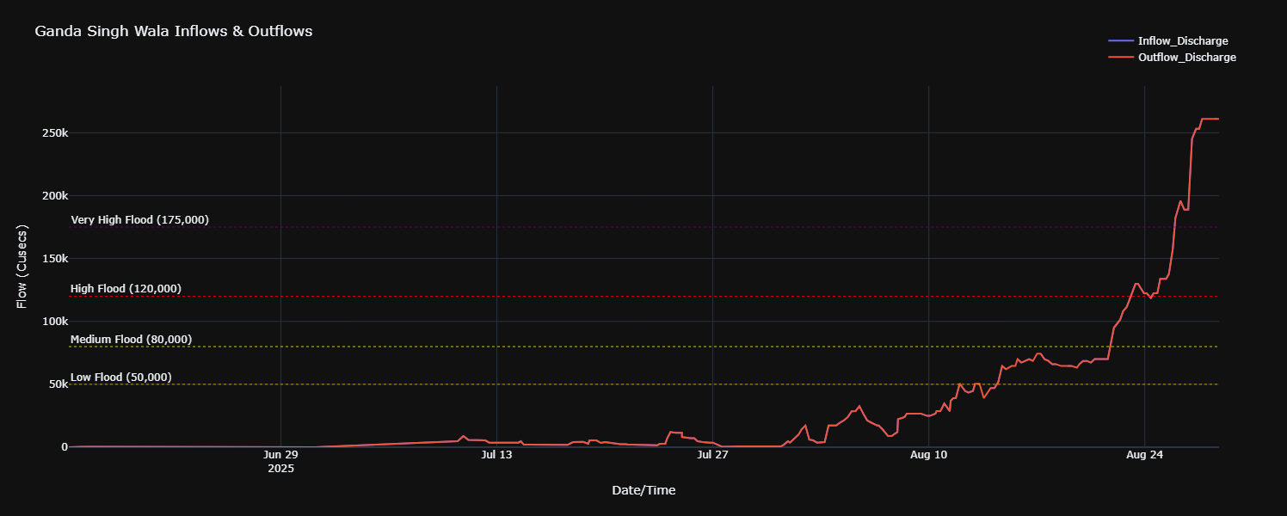

Figure Surge at Ganda Singh Wala, Sutlej River

**2. Vertical Rainfall Patterns in lower catchments of Pakistan**

1. High flows from across the border in the Chenab, Ravi, and Sutlej rivers were further aggravated when the districts of **Gujrat, Sialkot, Narowal, Wazirabad, Nankana Sahib, Gujranwala, Lahore, Sheikhupura and Kasur** experienced record rainfall of 200–370 mm within a very short duration. This intense precipitation caused widespread local flooding, including overflow of associated nullahs and severe urban flooding in Lahore, Sialkot, and Gujranwala, before converging into the Chenab and Ravi rivers, thereby amplifying already elevated flows. Furthermore, river levels in the Chenab and Ravi were compounded by saturated soil conditions in the lower catchment areas, which resulted in heavy surface runoff and significantly increased discharge.
2. The combined effect of **urban runoff** and **inadequate drainage systems** also magnified the impacts of the current flood in urban areas like Sialkot and Lahore.

**3. Interaction of Flows**

1. The vertical flows from intense rainfall, combined with horizontal transboundary inflows, converged within a short span of time at Marala, Khanki, and Qadirabad on the Chenab river. Similar convergence occurred at Jassar, Shahdara, and Balloki headworks on the Ravi, resulting in synchronized peak flows.
2. This synchronization was a critical factor in the escalation of the floods across north and south eastern Punjab.
3. **Current Flows in Major Rivers**
4. **Chenab River:**
   1. At **Marala Headworks**: The flow has now **subsided** to 163,440cusecs (medium flood level and declining further).
   2. At **Khanki Headworks**: The flow has now **subsided** to 335,956cusecs (very high flood level and declining further).
   3. At **Qadirabad Headworks**: The flow has now **subsided** to 534,509cusecs (very high flood level and declining further).
   4. At **Chiniot Bridge**: The flow has now **increased substantially** to 718,500cusecs (extremely high flood level and increasing further). The design capacity of the bridge is approx. 800,700cusecs and the high flow levels which passed through Qadirabad are now passing through this location and onwards to Trimmu barrage.

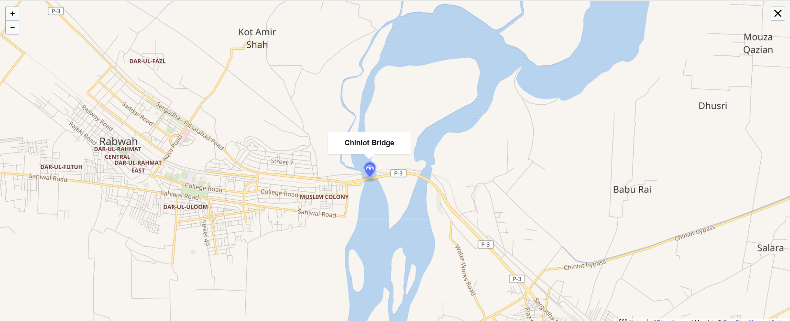

Figure Location of **Chiniot Bridge** on Chenab River

* 1. At **Trimmu Barrage**: The flow has now **increased** to 98,994cusecs (approaching low flood level of 150,000cusecs and increasing further). It is expected that the high flow currently upstream at Chiniot bridge will reach downstream at Trimmu Barrage on 31 August.

1. **Ravi River:**
   1. At **Kot Naina**: The flow has now **subsided** to 77,000cusecs (medium flood level and declining further).
   2. At **Jassar**: The flow has now **subsided** to 113,200cusecs (high flood level and declining further).
   3. At **Shahdara**: The flow has now **increased substantially** to 217,660cusecs (very high flood level and rising further). The design capacity at Shahdara is approx. 250,000cusecs and the high flow levels which passed through Jassar are now passing through this location and onwards to Balloki Headworks.
   4. At **Balloki Headworks**: The flow has now **increased** to 124,855cusecs (very high flood level and rising further). The design capacity of Balloki Headworks is approximately 380,000cusecs.
2. **Sutlej River:**
   1. At **Ganda Singh Wala**: The flow is **currently stable** at 261,053cusecs (extremely high flood level and steady).
   2. At **Sulemanki Headworks**: The flow has now **increased** to 113,124cusecs (medium flood level and rising).
3. **Flood ROUTING AND PEAK FLOW FORECAST**
4. **Chenab River:**

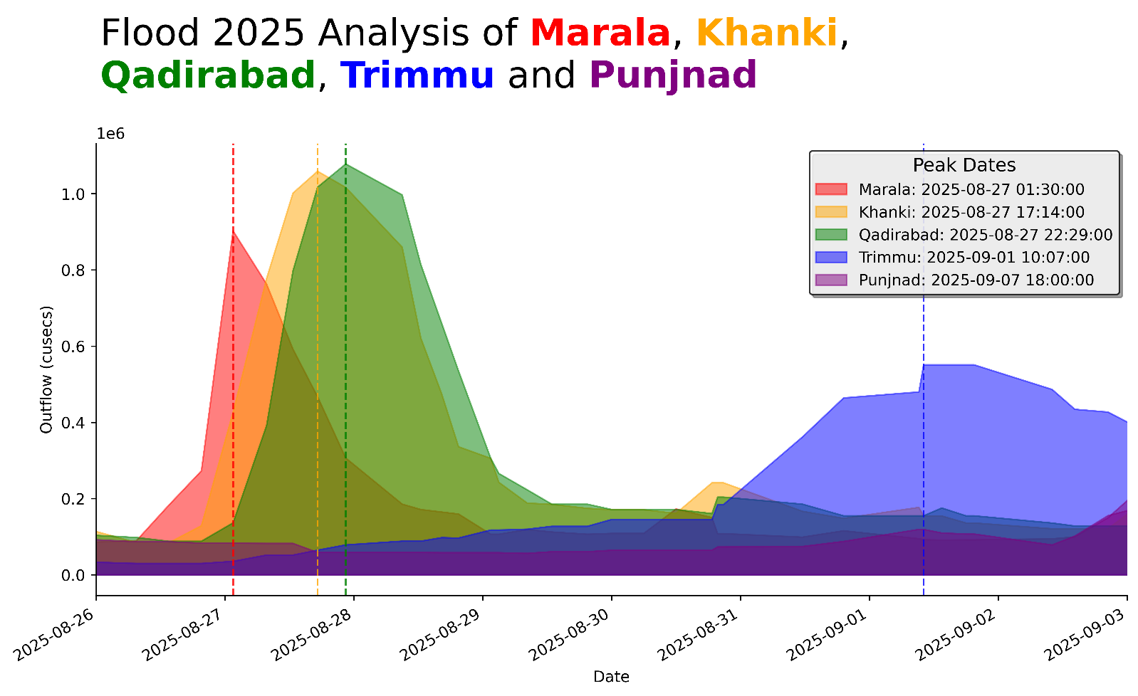

On 26th August 2025, heavy to very heavy rainfall occurred in the catchment areas of the Chenab, Ravi, and Sutlej rivers. Sialkot alone recorded more than 360 mm of rain in 24 hours, breaking a 49-year historical record. As a result, significant flood peaks were generated due to intense rainfall across north-eastern Pakistan including Lahore, Narowal, Sialkot, Gujrat, Kasur, Gujranwala and in the transboundary catchment areas of the eastern rivers.

In the Chenab River, a flood peak of 902,240 cusecs was recorded on 27th August at 0130 hrs. This was further intensified by contributions from local nullahs such as Aik, Phalku, Jammu Tawi, and Munawar Tawi originating from the Pir Panjal Range resulting in peak discharges of 1,085,750 cusecs at Khanki and 1,077,951 cusecs at Qadirabad (the highest since 1992), recorded at 1000 hrs and 1800 hrs on 27th August, respectively.

To reduce flood pressure, a controlled breaching section was activated at Qadirabad (RD 8000 of the Right Marginal Bund) with the assistance of the Pakistan Army's 30 Corps. The peak later reached Chiniot Bridge with a maximum discharge of 855,000 cusecs on 28th August. It then attenuated further at Trimmu Barrage, where the discharge dropped to 550,965 cusecs by 1st September due to both the earlier activation of a breaching section downstream of Chiniot Bridge near Rivaz Bridge and the long lag time and travel distance.

Currently, the first flood peak of the Chenab is passing through Multan and Muzaffargarh areas with estimated flows between 450,000 and 500,000 cusecs. At the confluence point of the Chenab and Ravi rivers in districts Jhang and Khanewal, an additional 110,000–120,000 cusecs are being added to the Chenab’s flow, also causing backwater effects at the junction. The combined flows from the Chenab, Ravi, and Sutlej rivers are expected to reach 550,000 to 600,000 cusecs at Panjnad Barrage by tonight or tomorrow afternoon.

On 7th–8th September, approximately 220,000 cusecs from the Indus River are expected to merge with the 550,000–600,000 cusecs from the Chenab system at Guddu Barrage bringing the total expected discharge to around 700,000 cusecs. This flood volume is forecast to take 32–36 hours to travel from Guddu to Sukkur, likely reaching there with around 600,000 cusecs on 8th–9th September.

On the Ravi River, a flood peak of 240,500 cusecs was recorded at Jassar on 27th August, caused by local nullah flows, heavy rainfall, and spillway releases from Thein Dam. This peak reached Shahdara Bridge with 219,770 cusecs on 28th August and then Balloki Headworks with 223,385 cusecs on 30th August after a 38-hour journey. From Balloki, the flood took another 71 hours to reach Sidhnai Headworks, where it peaked at 193,470 cusecs on 3rd September. As this exceeded Sidhnai design capacity of 175,000 cusecs, a breaching section was activated upstream at the Mai Safuran embankment to relieve pressure and ensure the structural safety of the headworks.

In the Sutlej River, extremely high flows have persisted at Ganda Singh Wala for the past 10 days, with a peak discharge of 385,569 cusecs recorded on 29th August. As of today, the flow remains high at 311,673 cusecs. At Suleimanki Headworks, the maximum recorded discharge was 154,219 cusecs on 31st August, with current flows around 140,000 cusecs. Islam Headworks is currently experiencing medium flows at 102,045 cusecs. The estimated flows from the Sutlej River to the overall system is around 100,000 cusecs.

Peak flows of the Chenab, exceeding 800,000 cusecs (without breaching) or 750,000–800,000 cusecs (with breaching section operation), are expected to reach Trimmu Headworks between 31 August and 1 September 2025 downstream of Qadirabad. Outflows from the Jhelum remain negligible, keeping the Chenab as the primary contributor. Given the extreme magnitude, a breach at Trimmu Headworks may become unavoidable to safeguard the structure.

This flood wave is projected to travel downstream, reaching Punjnad Headworks around midday on 3 September or during the night of 3/4 September, with peak inflows of approximately 750,000 cusecs.

The map below depicts all the flood affected UCs (Union Councils) along the path of the Chenab starting from Marala till Punjnad headworks.

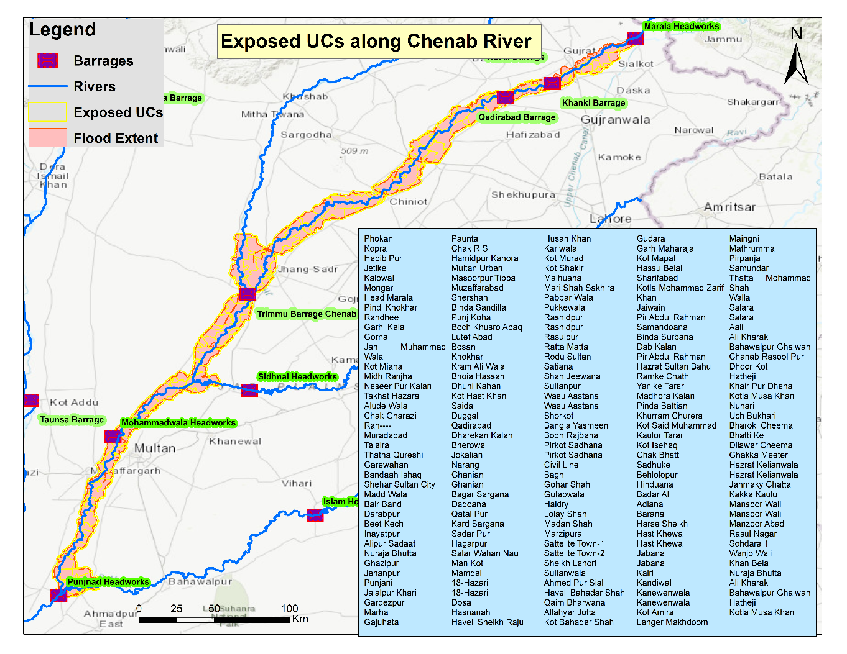

Figure **Chenab** affected UCs

1. **Ravi River:**

The Ravi is carrying peak flows of 125,000–150,000 cusecs, recorded at Shahdara and Balloki. These are forecast to converge downstream and reach Panjnad Headworks between the night of 2/3 September and midday 3 September. The timing indicates potential synchronization with the Chenab flood peak.

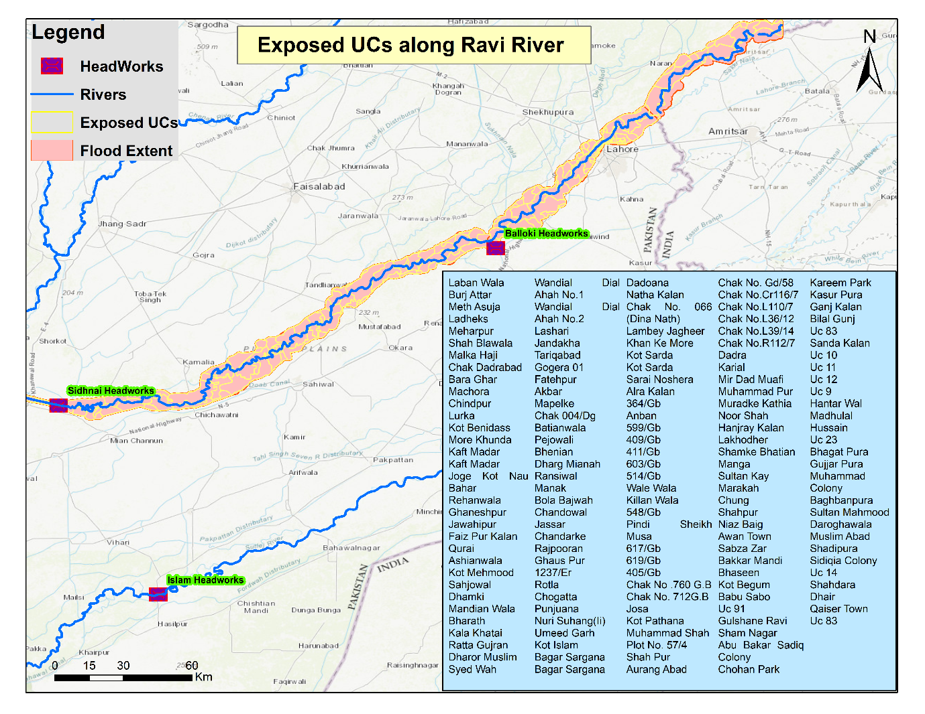

Figure **Ravi** affected UCs

1. **Sutlej River:**

At Ganda Singh Wala, flows of over **260,000 cusecs** have been observed. Routing through Sulemanki and Islam, the peak is expected to reduce and stabilize at around **150,000–175,000 cusecs** before entering **Panjnad Headworks on the night of 3/4 September or by midday 4 September**.

1. **Combined Flows at Panjnad Headworks**

Flows from the **Chenab, Ravi, and Sutlej are expected to overlap at Panjnad between 3–4 September 2025**. The combined inflows may reach 900,000–950,000 cusecs without breaching operations, or 825,000–900,000 cusecs if a breaching section is activated. This will place enormous hydraulic pressure on Panjnad Headworks, making the activation of an additional breaching section highly likely.

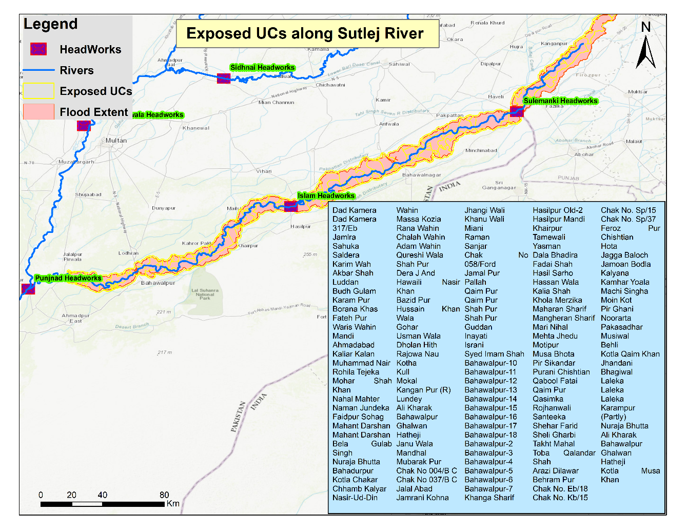

Figure **Sutlej** affected UCs

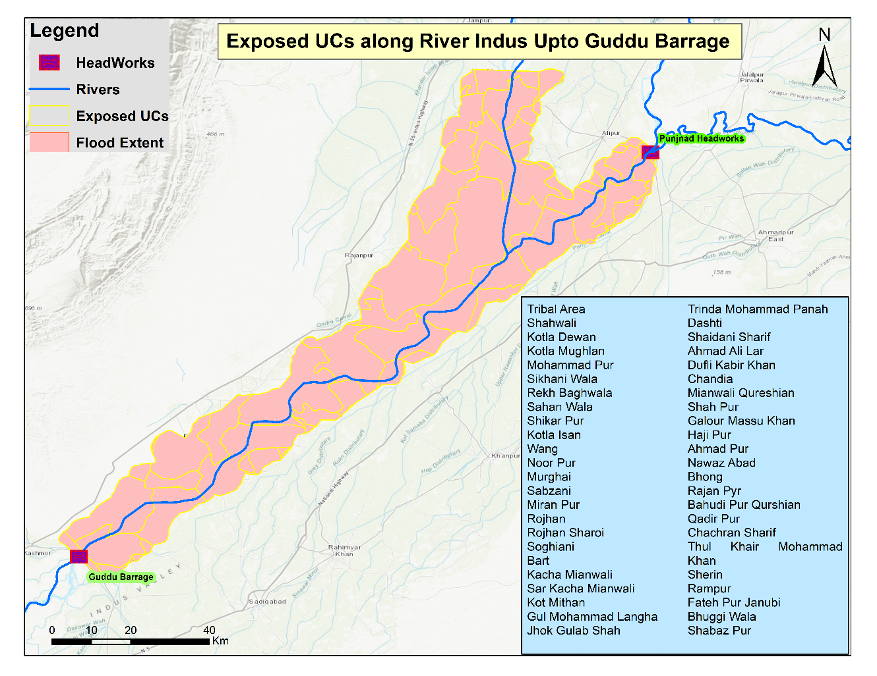

Figure Indus affected UCs (**Panjnad to Guddu**)

1. **Indus (Guddu Barrage and Downstream)**

Currently, inflows at **Guddu Barrage are around 300,000 cusecs**. With outflows from Panjnad (800,000–900,000 cusecs) expected to arrive by **5–6 September 2025**, the accumulated peak at Guddu could marginally exceed its design capacity of **1.2 million cusecs**, though remaining within a safe operational risk margin.

If **Indus inflows at Guddu are managed below 250,000 cusecs**, and **Panjnad breaching sections are operated**, peak floods at Guddu will remain **well within 1.2 million cusecs capacity**.

Sindh should remain on **high alert** to receive peak outflows from **Guddu Barrage in the range of 1.0–1.2 million cusecs**. These flows will travel downstream from Guddu through Sukkur and Kotri towards the Arabian Sea over the next **7–8 days (till 12–13 September 2025)**.

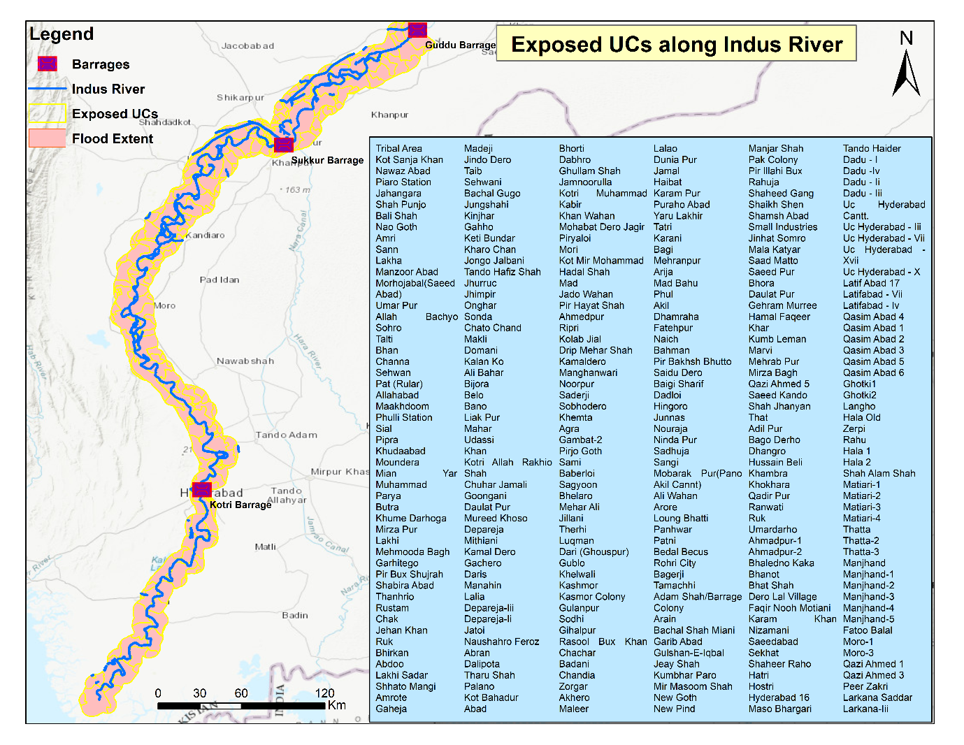

Figure **Indus** affected UCs (**Guddu to Arabian Sea**)

For a detailed exposition of the above projected flood routing, time lags and peak flows forecast please refer to **APPENDIX 1 – Flood Routing with Lag Time**.

1. **Comparison of 2014 AND 2025 FloodS**

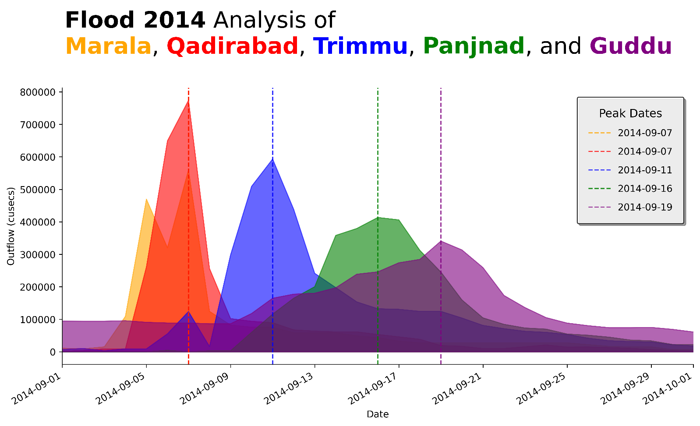

Figure 11 Peak analysis of 2014 flood in Chenab River

From Figure 11, it is evident that the lag time between Marala and Qadirabad during the 2014 flood event was approximately nine hours. During this interval, the flood peak decreased by 38.28% between Marala and Khanki, followed by an increase of 23.34% between Khanki and Qadirabad. The hydrograph indicates that it took nearly four days for the flood peak to travel from Qadirabad to Trimmu, where a further 30.30% reduction was observed, demonstrating significant attenuation over this reach.

Additional lag times are also apparent in Figure 11, with the flood peak requiring approximately five days to travel from Trimmu to Punjnad, accompanied by a 17.58% decrease, and an additional three days to propagate from Punjnad to Guddu. These observations collectively confirm the attenuation and transformation of the flood wave as it progresses downstream, primarily due to inundations, dispersion, surface roughness, slope, travel distance, and lag time.

Furthermore, detail comparison of flood 2014 and flood 2025 has been drawn in the table 1.

**Table 1 Comparative analysis of Flood 2014 and Flood 2025**

| **Aspect** | **2014 Flood** | **2025 Flood (Ongoing/Projected)** |
| --- | --- | --- |
| **Primary Rivers Impacted** | Chenab, Jhelum (Mangla), Ravi | Chenab, Ravi, Sutlej, Indus (downstream via Panjnad) |
| **Key Provinces/Districts Affected** | Punjab: Lahore, Gujranwala, Rawalpindi, Faisalabad, Sargodha; Upper Jhelum catchments | Punjab: Gujrat, Sialkot, Narowal, Wazirabad, Nankana Sahib, Gujranwala, Hafizabad, Lahore, Sheikhupura, Kasur, Jhang, Bahaw; downstream Sindh via Indus |
| **Peak Flows – Chenab** | 5 Sept 2014: 485,000 cusecs at Marala; 6 Sept: 865,000 cusecs peak | 26–27 Aug 2025: Surge from 200,000 → 1,100,000 cusecs at Marala (highest since 1957); projected 750,000–800,000 cusecs at Panjnad (3–4 Sept) |
| **Peak Flows – Ravi** | Contributed locally but not extreme compared to Chenab | Peaks of 290,000 cusecs at Kot Naina; 237,000 cusecs at Jassar; 217,660 cusecs at Shahdara (Lahore) |
| **Peak Flows – Sutlej** | Limited contribution in 2014 floods | 260,000+ cusecs at Ganda Singh Wala; projected 150,000–175,000 cusecs at Panjnad (3–4 Sept) |
| **Synchronization of Flood Peaks** | Mainly Chenab-driven, Jhelum (Mangla) moderated | Synchronization of Chenab + Ravi + Sutlej at Panjnad (3–4 Sept) – combined peak 900,000–950,000 cusecs |
| **Indus System Impacts** | Not significantly stressed in 2014 | Guddu Barrage projected 1.0–1.2 million cusecs (near design capacity) by 5–6 Sept 2025; downstream propagation to Sukkur & Kotri |
| **Rainfall Contribution (Pakistan side)** | Heavy rainfall in upper catchments (esp. Jhelum/Chenab) | Record local rainfall 200–370 mm in Punjab districts (urban flooding Lahore, Sialkot, Gujranwala); soil saturation worsened runoff |
| **Overall Flood Character** | Severe but more localized, Chenab-dominant | Multi-river, synchronized peaks; compound flood (cross-border inflows + extreme local rainfall); broader Punjab + Sindh risk |
| **Comparative Severity** | Major disaster (esp. Chenab flood of 865,000 cusecs) | More extreme: Chenab peaked higher, Ravi & Sutlej contributing, Indus downstream under stress; cumulative magnitude surpasses 2014 |

1. **IMPACT to date**
2. The Punjab province is so far affected by one of its worst floods in decades, with simultaneous high floods on the Ravi, Sutlej, and Chenab combined with record rainfalls in certain districts—the first such concurrence in decades, forcing multi-district disaster response including rescue and relief operations province-wide.
3. Provincial and federal updates report **~1.2 million people affected** and **~1.1 million+ evacuated/displaced** across >1,400 villages along the three rivers namely Chenab, Ravi and Sutlej.
4. Peak inflows in the river include **~261,000 cusecs at Ganda Singh Wala (Sutlej)**, **~217,660 cusecs at Shahdara (Ravi)**, and **1,100,000 cusecs routed through Marala, Khanki and Qadirabad Headworks on the Chenab**—exceeding local capacities and prompting breaches along with high-alert evacuation measures.

For detailed maps outlining impacted union councils in case of breaches at major points on the rivers please refer to **APPENDIX 2 – IMPACT OF BREACHES**.

1. These impacts stem from **intense monsoon rainfall** across upper and lower catchments **plus large releases from Indian reservoirs** (Ranjit Sagar/Thein, Pong, Bhakra; also Salal/Baglihar on the Chenab), rapidly amplifying downstream flows in Pakistan.
2. **Downstream risk (Trimmu-Panjnad-Sindh):** With multi-river peaks **converging toward Panjnad**, attention should be shifting to flows at Trimmu, Panjnad and **Indus barrages (Guddu→Sukkur→Kotri)** for potential high flows in early September; Guddu has already fluctuated between **low to medium flood (~300–340k cusecs)** this week.

**APPENDIX 1 - Flood Routing with Lag Time.**

|  |  |  |  |  |  |  |  |  |  |  |  |  |  |  |  |  |  |  |  |  |  |  |  |  |  |
| --- | --- | --- | --- | --- | --- | --- | --- | --- | --- | --- | --- | --- | --- | --- | --- | --- | --- | --- | --- | --- | --- | --- | --- | --- | --- |
| Rivers | Station Name | **Date and time** | | | | | | | | | | | | | | | | | | | | | | | |
| 28/08/2025 12:00 | 29/08/2025 18:00:00 pm | 29/08/2025 10:00 | 29/08/2025 7:00 | 29/08/2025 20:00 | 30/08/2025 5:00 | 30/08/2025 12:00 | 30/08/2025 17:00 | 31/08/2025 0:00 | 31/08/2025 4:00 | 31/08/2025 14:00 | 31/08/2025 21:00 | 01/09/2025 5:00 | 01/09/2025 10:00 | 02/09/2025 5:00 | 03/09/2025 1:00 | 03/09/2025 2:00 | 03/09/2025 13:00 | 03/09/2025 20:00 | 04/09/2025 11:00 | 04/09/2025 17:00 | 05/09/2025 7:00 | 05/09/2025 17:00 | 06/09/2025 0:00 |
| Chenab | **Marala** | 171264 |  |  |  |  |  |  |  |  |  |  |  |  |  |  |  |  |  |  |  |  |  |  |  |
| **Khanki** | 631295 |  |  |  |  |  |  |  |  |  |  |  |  |  |  |  |  |  |  |  |  |  |  |  |
| **Q.Abd** | 901506 | 568165.5 |  |  |  |  |  |  |  |  |  |  |  |  |  |  |  |  |  |  |  |  |  |  |
| **Trimmu** | 88375 | 64 Hrs | | | | | | | | 811355.4 |  |  |  | 568165.5 |  |  |  |  |  |  |  |  |  |  |
| **Panjnad** | 58732 | 81 Hrs | | | | | | | | | | 88375 |  |  |  |  |  | 730219.86 |  | 568165.5 |  |  |  |  |
| **Trimmu -Panjnad** |  |  |  |  |  |  |  |  |  |  |  | 88375 |  |  |  |  |  | 730219.86 |  |  |  |  |  |  |
| **Sidnai-Panjnad** |  |  |  |  |  |  |  |  | 10,067 |  |  |  |  |  |  |  |  |  | 117,200 |  |  |  |  |  |
| **Islam-Panjnad** |  |  |  |  |  |  |  |  |  |  | 52,706 |  |  |  |  |  | 109,305 |  |  |  |  | 190,000 |  |  |
| Ravi | **Jassar** | 128,250 |  |  |  |  |  |  |  |  |  |  |  |  |  |  |  |  |  |  |  |  |  |  |  |
| **Shahdara** | 183,118 | 22 Hrs | 128,250 |  |  |  |  |  |  |  |  |  |  |  |  |  |  |  |  |  |  |  |  |  |
| **Balloki** | 89,850 | 19 Hrs | | 183,118 |  |  |  |  |  |  |  |  |  |  |  |  |  |  |  |  |  |  |  |  |
| **Sidhnai** | 10,067 | 48 Hrs | | | | | 89,850 |  |  |  |  |  | 146,500 |  |  |  |  |  |  |  |  |  |  |  |
| Sutlej | **Ganda Singh Wala** | 261,053 |  |  |  |  |  |  |  |  |  |  |  |  |  |  |  |  |  |  |  |  |  |  |  |
| **Sulemanki** | 109,305 | 53 Hrs | | | | | | 250,000 |  |  |  |  |  |  |  |  |  |  |  |  |  |  |  |  |
| **Islam** | 52,706 | 60 Hrs | | | | | | | 109,305 |  |  |  |  |  | 225,000 |  |  |  |  |  |  |  |  |  |
| Indus | **Guddu** | 300,232 |  |  |  |  |  |  |  |  |  |  |  |  |  |  |  |  |  |  |  |  |  |  |  |
| **Punjnad - Guddu** |  |  |  |  |  |  |  |  |  |  |  |  |  |  |  | 88375 |  |  |  |  |  | 109,305 | 650,000 | 117,200 |
| **Sukkar** | 212,300 |  |  |  | 300,232 |  |  |  |  |  |  |  |  |  |  |  |  |  |  |  |  |  |  |  |
| **Kotri** |  |  |  |  |  |  |  |  |  |  |  |  |  |  |  |  |  |  |  |  | 212,300 |  |  |  |

**APPENDIX 2 – IMPACT OF BREACHES**

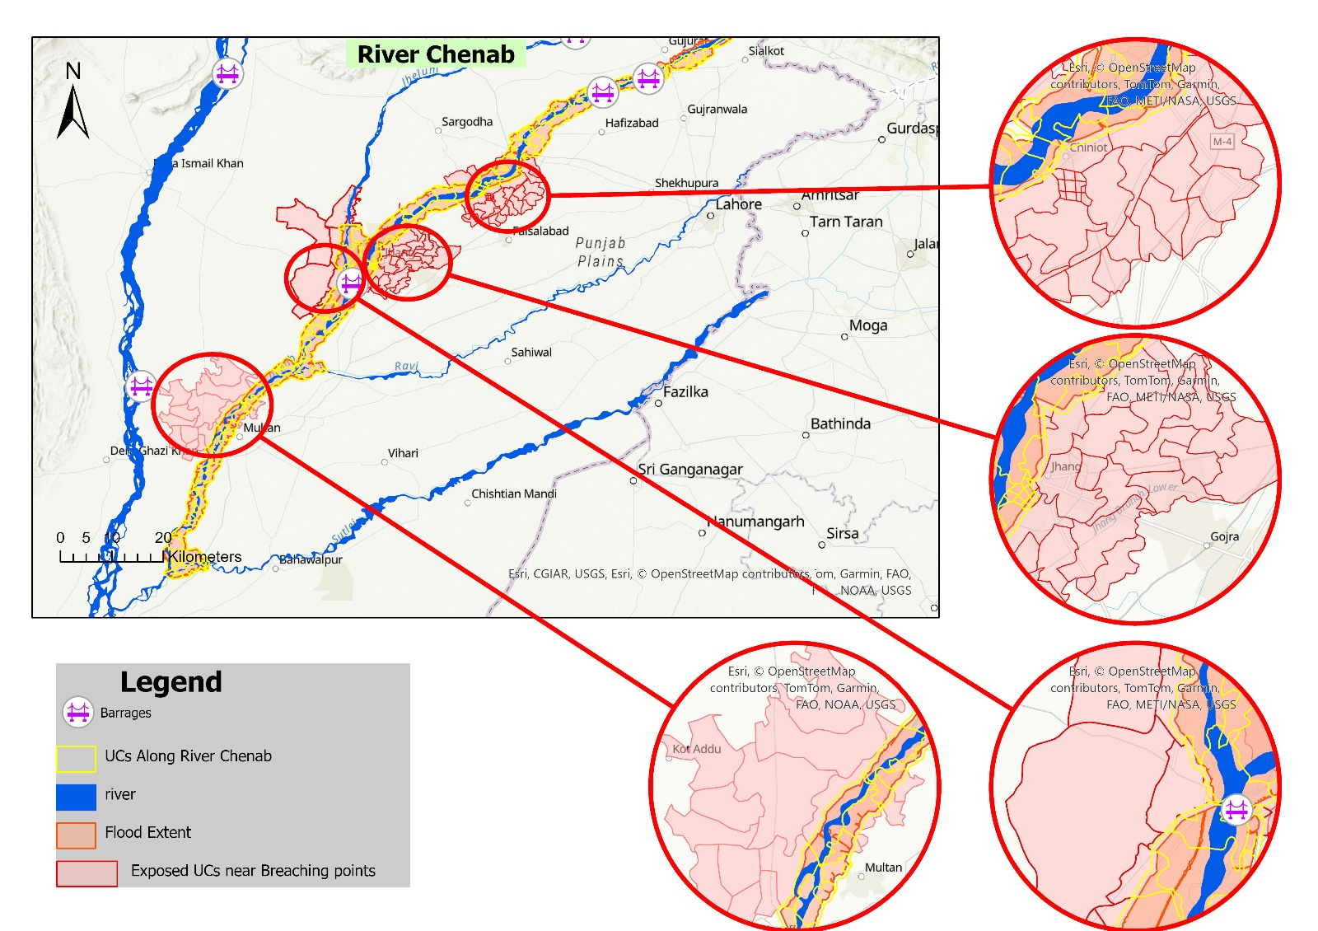

Figure Impact of Breaches on **Chenab (Chiniot, Jhang, Multan)**

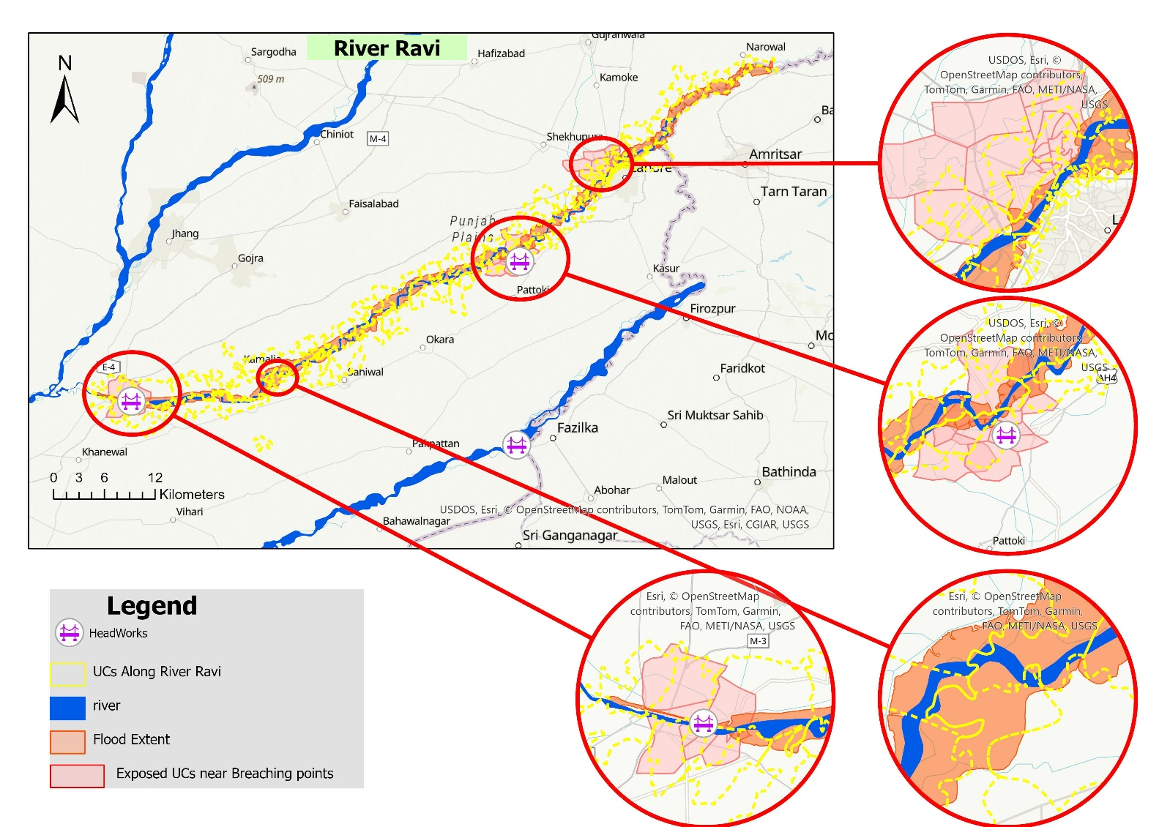

Figure Impact of Breaches on **Ravi (Shahdara, Balloki, Sidhnai)**

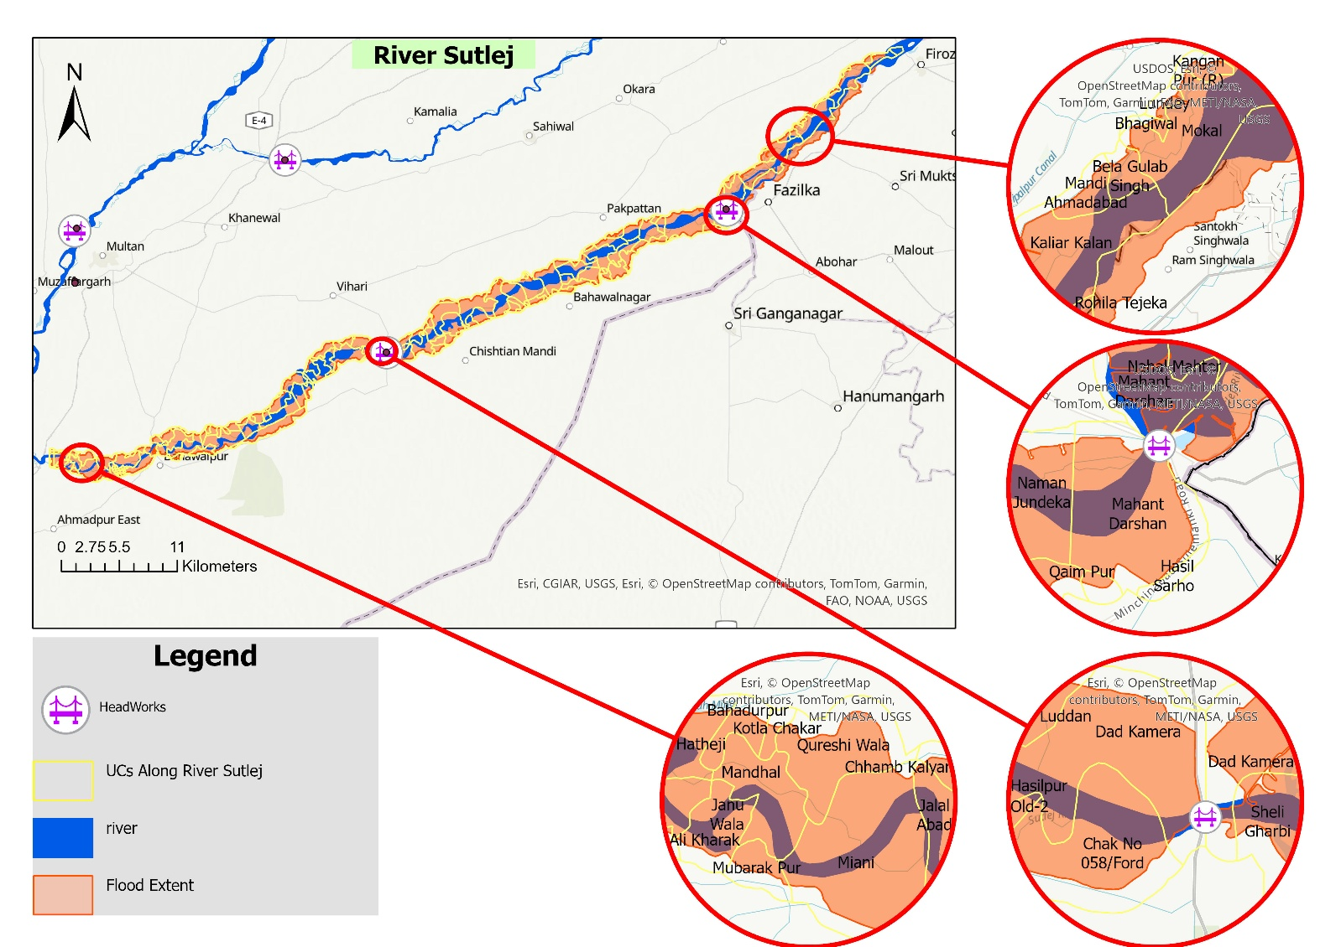

Figure Impact of Breaches on **Sutlej (Ganda Singh Wala, Sulemanki, Islam)**